Uber Trip Data Analysis

SQL Insights Report

Name: Abhinava Sajeev

Date: June 19, 2025

# 1. Introduction

This report provides SQL-based insights from Uber ride request data. The dataset includes information such as pickup points, ride status, timestamps, and driver details. The goal is to identify patterns and inefficiencies in trip completions, cancellations, and service gaps.

# 2. SQL Insights

## 2.1 When are there supply gaps (No Cars Available) at the Airport in the morning?

SQL Query:

-- Get total requests and 'No Cars Available' rate at the Airport between 5 AM and 9 AM  
SELECT   
 request_hour,  
 COUNT(*) AS total_requests,  
 SUM(status = 'No Cars Available') AS no_car,  
 ROUND(SUM(status = 'No Cars Available') * 100.0 / COUNT(*), 2) AS no_car_rate  
FROM uber_requests  
WHERE pickup_point = 'Airport' AND request_hour BETWEEN 5 AND 9  
GROUP BY request_hour  
ORDER BY request_hour;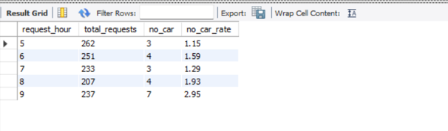

Insight:

High 'No Cars Available' rates were observed between 5 AM and 9 AM at the Airport, indicating a morning supply shortage.

## 2.2 Are there more cancellations in the City during evening hours?

SQL Query:

-- Get total requests and cancellation rate in the City between 5 PM and 9 PM  
SELECT   
 request_hour,  
 COUNT(*) AS total_requests,  
 SUM(status = 'Cancelled') AS cancelled,  
 ROUND(SUM(status = 'Cancelled') * 100.0 / COUNT(*), 2) AS cancel_rate  
FROM uber_requests  
WHERE pickup_point = 'City' AND request_hour BETWEEN 17 AND 21  
GROUP BY request_hour  
ORDER BY request_hour;

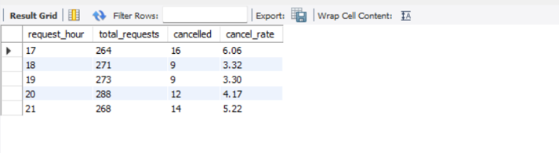

Insight:

Cancellation rates spike in the City during evening peak hours, possibly due to traffic or driver unavailability.

## 2.3 Which pickup point has better trip completion rates?

SQL Query:

-- Compare total completed trips and completion rate for each pickup point  
SELECT   
 pickup_point,  
 SUM(status = 'Trip Completed') AS completed,  
 COUNT(*) AS total,  
 ROUND(SUM(status = 'Trip Completed') * 100.0 / COUNT(*), 2) AS completion_rate  
FROM uber_requests  
GROUP BY pickup_point;

Insight:

City trips tend to have a higher completion rate compared to Airport trips, likely due to easier access and quicker turnarounds.

## 2.4 What is the overall status breakdown of all ride requests?

SQL Query:

-- Show the number and percentage of each trip status (Completed, Cancelled, No Cars)  
SELECT   
 status,  
 COUNT(*) AS total,  
 ROUND(COUNT(*) * 100.0 / (SELECT COUNT(*) FROM uber_requests), 2) AS percent  
FROM uber_requests  
GROUP BY status;

Insight:

Nearly half of the ride requests are not completed, with a significant portion due to 'No Cars Available' and cancellations.

## 2.5 How does ride failure (cancellation or no cars) vary by hour?

SQL Query:

-- Analyze hourly failure rates: cancellations and no car availability  
SELECT   
 request_hour,  
 COUNT(*) AS total_requests,  
 SUM(status = 'Cancelled') AS cancelled,  
 SUM(status = 'No Cars Available') AS no_cars,  
 ROUND(SUM(status = 'Cancelled') * 100.0 / COUNT(*), 2) AS cancel_rate,  
 ROUND(SUM(status = 'No Cars Available') * 100.0 / COUNT(*), 2) AS no_cars_rate  
FROM uber_requests  
GROUP BY request_hour  
ORDER BY request_hour;

Insight:

Peak hours in the evening and early morning show a high percentage of failed requests, highlighting critical service pressure windows.

## 2.6 How are different ride statuses distributed by pickup point?

SQL Query:

-- Show how each status (Completed, Cancelled, No Cars) is distributed by pickup point  
SELECT   
 pickup_point,  
 status,  
 COUNT(*) AS total  
FROM uber_requests  
GROUP BY pickup_point, status  
ORDER BY pickup_point, total DESC;

Insight:

The Airport experiences more 'No Cars Available' issues, while the City has more cancellations. This indicates operational differences between zones.

## 2.7 What is the average trip duration for completed trips?

SQL Query:

-- Get average trip duration for each pickup point, considering only completed trips  
SELECT   
 pickup_point,  
 ROUND(AVG(trip_duration), 2) AS avg_duration  
FROM uber_requests  
WHERE status = 'Trip Completed'  
GROUP BY pickup_point;

Insight:

Average trip durations vary slightly between Airport and City pickups, offering insights into route efficiency and fare structure.

## 2.8 Which drivers handled the most trip requests?

SQL Query:

-- Show the top 5 drivers with the most total trip requests  
SELECT driver_id, COUNT(*) AS total_trips  
FROM uber_requests  
WHERE driver_id IS NOT NULL  
GROUP BY driver_id  
ORDER BY total_trips DESC  
LIMIT 5;

Insight:

The top 5 most active drivers handled the highest number of ride requests, highlighting potential candidates for reward or performance analysis.

# 3. Summary & Recommendations

The analysis reveals clear patterns of inefficiencies during specific times of the day, especially during early mornings at the Airport and evenings in the City. Recommendations include increasing driver availability through incentives during peak hours, and potentially refining the pickup process at the Airport to reduce delays and cancellations. Further analysis could involve heatmaps or trip density plots using Python.